Housing Choice Voucher use in Los Angeles County

*Project Description & Motivation*

The Housing Choice Voucher (HCV) program, also known as Section 8, is the largest housing program in the country. HCVs provide very low-income households with subsidies that help them afford safe and decent housing in the public rental market. Households who use vouchers are disproportionately likely to be people of color, and include women, children, and people with disabilities.[1] Vouchers play a pivotal role in alleviating housing insecurity, curbing homelessness, and mitigating hardships for families, while simultaneously fostering improved educational and developmental outcomes for children.[2] Los Angeles County (LA) has multiple housing subsidy programs, encompassing over 58,000 annual tenant-based rental subsidies.[3] Despite these initiatives, a considerable challenge persists – a significant number of households equipped with vouchers find themselves unable to utilize them due to difficulties in securing landlords willing to accept housing subsidies. In LA alone, more than 7,000 allocated housing vouchers, constituting 15.1%, remain unused each year.[4] Despite the enactment of a 2019 ban on source of income discrimination which made it illegal to refuse to rent to subsidy recipients in LA because of their source of income,[5] [6] concerns persist about the widespread discrimination.[7] [8]

The preliminary analysis of HCV use included in this document is part of a larger dissertation project that uses a sequential explanatory design. This preliminary analysis of HCV data is designed to answer two research questions:

1. What types of units are rented using HCVs in Los Angeles, and have there been changes in trends between 2017 and 2022?
2. Are there racial or demographic trends in the types of units voucher households rent?

The analysis of HCV data done to answer these questions will inform the development of a survey of landlords in LA County about the factors that shape their willingness to rent to HCV households, which will in turn inform qualitative data collection via focus groups about potential policy interventions to improve voucher use rates. To answer the above research questions, this a preliminary of Los Angeles County HCV data from 2017 through 2022, from the Housing and Urban Development Department’s Assisted Housing: National and Local data set.[9] This write-up describes the findings, limitations, and future directions for this work.

*RQ1: What types of units are rented using HCVs?*

Zip code level HCV data was analyzed to understand what types of units are rented using HCVs in Los Angeles. For each zip code, the number of vouchers used and certain demographics describing the households who lease units using HCVs are available. However, household level data is not available. For data privacy purposes, most descriptive data on household composition is hidden if there are fewer than 11 voucher households in a zip code. However, the total number of vouchers used in a given zip code by year is available for all zip codes.

One important question that has been raised about the efficacy of the HCV programs in expensive and competitive rental markets is whether households who are issued vouchers are able to use them. The maximum allowable rent covered by a voucher varies by family size and geographic region. The maximum allowable rent is set annual for each Public Housing Authority (PHA) based on the rental rates in their region based on either the 40th or 50th percentile rents. This maximum allowable rental rate is called the Fair Market Rate (FMR). FMRs are calculated by HUD for 2-bedroom units, and then scaled up and down based on the 2-bedroom rate calculation for other rental unit sizes. HCV households are eligible to rent a specific sized unit base don the number of family members in their household and the national occupancy standards. For example, the FMR for the units in the Housing Authority of Los Angeles’ (HACLA) jurisdiction for 2024 are included below.

Table 1: 2023 and 2024 Fair Market Rates for Rental Units in the Housing Authority of

the City of Los Angeles’ Jurisdiction

|  |  |  |  |  |  |
| --- | --- | --- | --- | --- | --- |
| Year | Efficiency | One-Bedroom | Two-Bedroom | Three-Bedroom | Four-Bedroom |
| 2023 | $1,777 | $2,006 | $2,544 | $3,263 | $3,600 |
| 2024 | $1,534 | $1,747 | $2,222 | $2,888 | $3,170 |

Source: FY 2024 Fair Market Rent Documentation System, HUD

Households with voucher receive rental assistance up to the allowable FMR based on their PHA and unit size. If a household receives zero income annually, then they receive then the voucher can be used to cover their rent up to the full value of the voucher. However, if households receive some annual income, then they pay 30% of their rent towards rent each month. If the unit is slightly more expensive than the FMR then households are allowed to pay the difference between the maximum voucher amount and the monthly rent out of pocket. However, households who rent units below the maximum allowable rent do not receive any funds or incentive for renting more affordable units. To rent a unit using an HCV, households must apply to units on the private market and the unit needs to pass a habitability inspection conducted by the local PHA to ensure that the unit meets habitability codes and standards.

In regions with highly variable rental rates like the Los Angeles Metro region, it can be difficult for voucher holders to use their voucher in certain geographic areas. For example, if a voucher household wanted to rent a unit in an affluent area like Beverly Hills, they have the same maximum rental cap as they would if they were applying to rent a unit in a lower-cost area in the Los Angeles Metro region like the Antelope Valley. In practice, this means that while voucher holders can technically rent anywhere in Los Angeles, because many areas have very high rents certain areas of Los Angeles are not available to voucher households because the rents are too high. To combat this issue, some PHAs have started using Small Area Fair Market Rents (SAFMR) which determine the annual maximum voucher value per unit size based on zip code. For example, if SAFMRs were adopted in LA the same household trying to rent a two-bedroom in Beverly Hills would have a maximum voucher value above the 2024 FMR rate of $2,544 for Los Angeles County. However, if this family tried to rent in a low-cost zip code in Antelope Valley their available voucher value for a two-bedroom would be less than $2,544.

Voucher pricing has important equity implications for households who have been issued or who are using an HCV. A selling point of the HCV program was that, unlike public housing, it allowed households the opportunity to move to neighborhoods where they wanted to live. Meaning that households could move to high opportunity neighborhoods with better schools and jobs, unlike public housing which came under fire for pushing poor people into living in neighborhoods with concentrated poverty and fewer job and educational opportunities. While promising in theory, this idea of how vouchers can be used has many limitations in practice. Many voucher holders still live in high poverty neighborhoods with limited access to high opportunity neighborhoods. Additionally, some research has shown that white households with vouchers are more likely to live in lower poverty neighborhoods while households of color are less likely to live in low poverty neighborhoods. Some research has suggested that the racial and ethnic differences in access to low-poverty neighborhoods may be due to racial discrimination by landlords and property managers, and others have suggested that voucher households of color may prefer to live high-poverty neighborhoods that are predominantly communities of color if the low-poverty neighborhoods in their region are predominantly white. Additionally, patterns of voucher use and access to low-poverty neighborhoods are further constrained in competitive rental markets like Los Angeles’ and in regions with a wide variation in rental pricing because voucher holders who are by definition very low-income cannot afford to live in areas which rents falling significantly above FMR.

While Los Angeles does not use SAFMRs to determine the values of a voucher, SAFMRs are calculated annually by HUD for Los Angeles. To understand the prices of units available to voucher holders in Los Angeles between 2017 and 2020, we calculated the relationship between the SAFMRs of the zip codes where units were rented with the annual FMR which were graphed using an area graph, and represented by a smoothing line to reduce noise in the visual. The smoothing lines representing the annual trends for 2017-2022 are reflected in Figure 1. In 2017, the first year graphed, the distribution of vouchers is closer to normal but skewed right, meaning that voucher household are renting units below and above FMR but more households are renting units above FMR. Between 2021 and 2020 the majority of HCV units rented at around 1.2 FMR, meaning that most voucher households were paying at least 20% of their rent out of pocket because the rental rate falls above FMR. For households with income, in addition to the amount they pay above the maximum allowable voucher value, they would also pay 30% of their monthly income in rent. In 2021 and 2022 the majority of HCV households are renting at 10% above FMR. Figure 2 shows how these annual trends relate to one another by superimposing the smoothing lines for each year from the individual graphs shown in Figure 1.

**Figure 1: Number of units rented in zip codes with SAFMR below, at and above FMR**

**Figure 2: Smoothed line graph of units rented in zip codes with SAFMR below, at and above FMR**

It is useful to compare how the number of units rented in zip codes with a given SAFMR compares to the annual FMR because the rates change annually to account for inflation and changes in rental market pricing. Looking at how the number of units rented in zip codes where rental units are more or less expensive than the voucher holders maximum voucher amount is telling of the types of units available to HCV households and the constraints they face when renting.

The fact that the distribution of the number of units rented at each price point is not closer to normal or skewed to the left is surprising. A normal distribution for these years would reflect that HCV households are just as likely to rent above in zip codes with units typically falling at prices above and below FMR. A left skewed distribution would suggest that HCV households tend to rent in zip codes where rents are typically at or below FMR, which would make sense because if the unit they rent is at or below FMR then HCV households who are low income would then not need to pay additional rent out of pocket to account for rent amounts above the maximum allowable voucher value. However, we see that after 2017 the smoothed lined of rental patterns in Figure 2 increase exponentially for years 2018 through 2022. Across all years, the majority of HCV households in LA County are renting in zip codes with SAFMRs about their maximum voucher value, which may suggest that these households are unable to find rental units at lower price points using their vouchers. This could be due to a number of different factors like source of income discrimination, the competitiveness of LA’s rental market, or the pricing of the FMR rate being too low to reasonable afford an apartment. Further data collection and analysis is needed to understand this trend. The qualitative data collection component of this study may help offer additional insight into why most HCV households in LA are renting in zip codes above their price range which may require them to pay additional rent out of pocket on to of the 30% of their monthly income that they pay their landlord.

In addition to understanding what price points HCV households are renting at, considering where they are living and how their neighborhoods shape access to opportunities is also a reflection of how effective the HCV program is in LA. One metric that can be used to reflect access to opportunities is the poverty level in a given zip code. To understand what types of neighborhoods HCV households are living in, how their neighborhoods shape their quality of life and opportunities, and to examine whether there are racial or ethnic disparities in access to low poverty neighborhoods in LA, the total number of units was regressed on the poverty rate zip codes where HCV households live in LA. Figure 1 shows the relationship between the total number of units and the poverty rate of the zip codes voucher holders reside in for all voucher holders in LA. Figure 4, Figure 5 and Figure 6 show the same analysis for White, Black, and Hispanic households respectively.

Figure 3 shows that there is a positive relationship between the poverty of zip codes where HCV households rent and the number of units rented. The relationship trends upwards and the trend gets steeper for later years. This reflects that most HCV households live in high poverty neighborhoods and that the number of HCV households living in high poverty neighborhoods is increasing each year in LA. This regression has a p-value of < 2.2e-16showing that there is a statistically significant relationship between the number of units rented by HCV households in a zip code and the poverty level in that zip code.

Figure 4, Figure 5, and Figure 6 show the same analysis conducted for white, Black, and Hispanic households. The regression of number of units rented by white HCV households on poverty level and the regression of the number of units rented by Black HCV households by poverty level are both statistically significant, with respective p-values of 6.273156e-27 and 1.904072e-31. However, the p-value for the analysis of the number of Hispanic HCV households renting units on the poverty level of a given zip code was 0.8193, meaning that the analysis is not statistically significant.

Unlike the trends for all HCV households, Figure 4 shows that there is a negative relationship between the poverty level in a zip code and the number of white HCV households living in that zip code. This trend is true for all years and the later years in the data set show that regression line starts lower on the y-axis, meaning that HCV households in LA are living in neighborhoods with decreasing poverty rates.

Figure 5 shows an upward trend in the regression, meaning that the higher the poverty rate in a zip code the greater the number of Black HCV households in the neighborhood. However, similar to Figure 4, the later years included in this graph start lower on the y-axis. The regression is also getting slightly less steep for later years, indicating that while zip codes with higher levels of poverty have more Black HCV households this trends is becoming slightly less severe over time.

**Figure 3: Regression of total number of units rented by HCV households on zip code poverty rate**

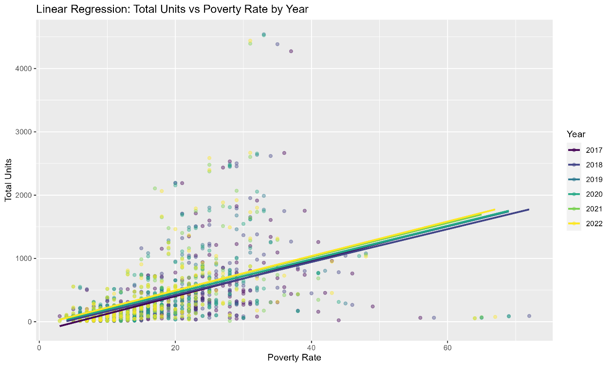

**Figure 4: Regression of total number of units rented by white HCV households on zip code poverty rate**

**Figure 5: Regression of total number of units rented by Black HCV households on zip code poverty rate**

[Figure coming soon. I created it but am running into issues exporting]

**Figure 6: Regression of total number of units rented by Hispanic HCV households on zip code poverty rate**

[Figure coming soon. I created it but am running into issues exporting]

**Limitations:**

This analysis has several limitations related to the level of detail available in HUD’s Assisted Housing data set. Because the data given is aggregated at the zip code level it is not possible to conduct intersectional analysis related to specific demographic characteristics. For example, the analysis above shows that Black HCV households are more likely to live in higher poverty neighborhoods. While it would be possible to conduct a similar analysis to show how likely households led by a disabled head of household are to live in high poverty neighborhoods, it is not possible to examine how likely households with disabled Black heads of household are to live in high poverty neighborhoods. We know that a households intersectional identity shapes their house needs and the systemic barriers they face. However, intersectional analysis cannot be completed using these data.

Additionally, to protect the privacy of HCV households, most demographic data is not available in the HUD Assisted Housing data set if there are 11 or fewer HCV households in a given zip code. Because of this, the above analysis which examines the neighborhoods poverty levels of different HCV households could not be conducted for additional race and ethnicity groups included in the data set because they had over 20% of their data points missing which would make the analysis less reliable.

**Future Directions:**

In addition to the analysis included in this document, I plan to complete further analysis of HCV use in Los Angeles as part of my dissertation. One of my future aims is to compare the number of vouchers issued and demographics of the households they were issued to with the number of vouchers actually used to rent a unit and the demographics of the households that were able to use their voucher. Demographic data collected at both the time the voucher is issued and when the voucher unit is leased up include household race/ethnicity, disability status, whether the household is experiencing homelessness, annual income, the household’s prior zip code and zip code it is used in, and the date the voucher is issued and when it is used. These data are collected by HUD but are not publicly available but have been previously shared with researchers to examine housing voucher use in Los Angeles. In 2020, Abt Associated released a report that examines the difference between the number of vouchers issued to people experiencing homelessness versus the number of vouchers used by people experiencing homelessness.[10] I plan to request access to these data from HUD’s Office of Policy Development and Research.

The analysis of HCV issuance and use data will inform the development of a survey on landlords in Los Angeles. The survey will collect data on landlord decision making, and the considerations that shape a landlord’s decision to rent to a voucher holder. The survey will collect data on four different realms that preliminary analysis and prior research has shown impact landlord decision making when working with voucher holders, these are: (1) biases and preconceived notions about voucher holders and sub-groups within the voucher holder population,[11] (2) experience working with agencies that administer housing voucher like public housing authorities or nonprofits,[12] (3) impact of incentives intended to encourage landlord participation,[13] and (4) willingness to price discriminate against voucher holders.

1. Goodman, L., Kaul, K., & Stegman, m. (2022) Leveraging Financing to Encourage Landlords to

   Accept Housing Choice Vouchers. Urban Institute.

   https://www.urban.org/sites/default/files/2022-09/Leveraging%20Financing%20to%20Encourage%20Landlords%20to%20Accept%20Housing%20Choice%20Vouchers.pdf
2. Fischer, W. (2015). Research Shows Housing Vouchers Reduce Hardship and Provide Platform for Long-Term Gains for Children. *Center on Budget and Policy Priorities*. https://www.cbpp.org/research/research-shows-housing-vouchers-reduce-hardship-and-provide-platform-for-long-term-gains
3. https://abc7.com/section-8-housing-city-of-los-angeles-hacla-public/13240363/#:~:text=Our%20data%20team%20found%20that,%2C%2085%25%20are%20being%20used.
4. *Ibid.*
5. Khouri, A. (2022). LA City Council votes to ban low-income Section 8 rental discrimination. *Los Angeles Times*. https://www.latimes.com/business/la-fi-section-8-discrimination-20190618-story.html
6. NBC Los Angeles. (2019). LA County Bans Discrimination Against Section 8 Tenants. *NBC Los Angeles*. https://www.nbclosangeles.com/news/la-bans-discrimination-against-section-8-tenants/149356/
7. Abraham, R. (2023). LA Isn’t Enforcing Its Section 8 Discrimination Ban. Could This Lawsuit Change the Tide? *Shelterforce*. https://shelterforce.org/2023/05/26/la-isnt-enforcing-its-section-8-discrimination-ban-could-this-lawsuit-change-the-tide/
8. Khouri, A. (2022). California outlawed Section 8 housing discrimination. Why it still persists. *Los Angeles Times*. https://www.latimes.com/california/story/2022-11-19/california-outlawed-section-8-housing-discrimination-why-it-still-persists
9. [Assisted Housing: National and Local | HUD USER](https://www.huduser.gov/portal/datasets/assthsg.html#codebook_2009-2023)
10. [Abt Single-Sided Body Template (hiltonfoundation.org)](https://www.hiltonfoundation.org/wp-content/uploads/2022/07/Abt_Voucher-Report_FINAL_7.8.22.pdf)
11. Cunningham, M., Galvez, M., Aranda, C. L., Santos, R., Wissoker, D., Oneto, A., Pitingolo, R., & Crawford, J. (2018). *A Pilot Study of Landlord Acceptance of Housing Choice Vouchers*. U.S. Department of Housing and Urban Development. https://www.huduser.gov/portal//portal/sites/default/files/pdf/Landlord-Acceptance-of-Housing-Choice-Vouchers.pdf
12. Garboden, P., Rosen, E., Creig, M., DeLuca, S., & Edin, K. (2018). *Urban Landlords and the Housing Choice Voucher Program: A Research Report.* US. Department of Housing and Urban Development. https://www.huduser.gov/portal/sites/default/files/pdf/Urban-Landlords-HCV-Program.pdf
13. *Ibid.*